**HALMASHAURI YA WILAYA YA MEATU**

**Ofisi ya Mkuu wa Shule,**

Shule ya Sekondari Mwamishali,

S.L.P. 242,

**MEATU – SIMIYU.**

**Mkoa wa Simiyu 13-12-2020.**

**Tel. Na: +255658624141**

**+255620697639**

**Kumb. Na. HWM/MSS/JI/VOL.1/2020**

Jina la Mwanafunzi:

________________________________________

S.L.P 44

MEATU – SIMIYU.

**YAH: KUCHAGULIWA KUJIUNGA NA KIDATO CHA KWANZA MWAKA 2021 KATIKA SHULE YA SEKONDARI MWAMISHALI :**

1. **UTANGULIZI**

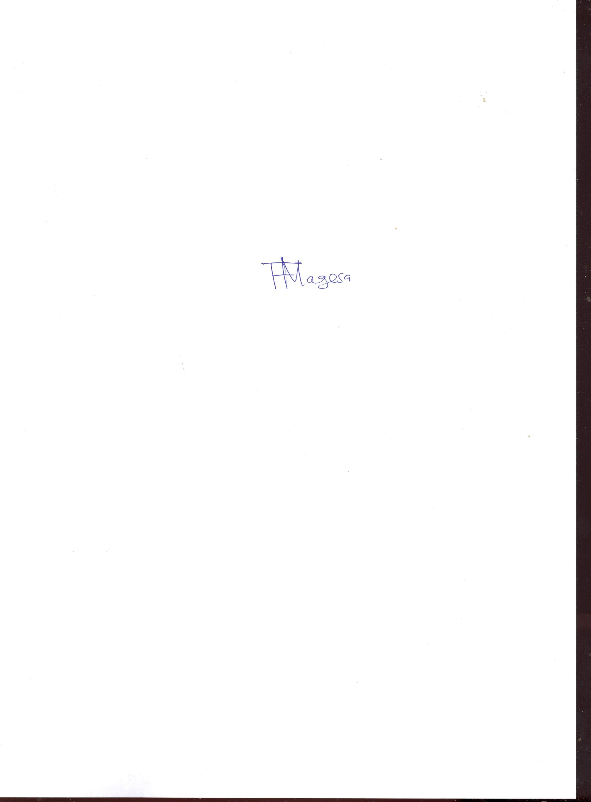Ninafurahi kukutaarifu kwamba, umechaguliwa na Wizara ya Elimu, Sayansi, Teknolojia na Ufundi kujiunga na kidato cha kwanza (I) 2021 katika Shule ya Sekondari Mwamishali. Shule hii ni ya kutwana mchanganyiko hivyo utahitajika kijitegemea Chakula na Malazi, gharama za usafiri wa kwenda shuleni na kurudi nyumbani pamoja na matibabu kwa muda wote wa masomo. Shule ipo katika kijiji cha **Mwamagingo,**Kitongoji cha **Mwashede** mkabala na na shule yaMsingi**Bulyashi ‘B’** , umbali wa kilomita 20 Kusini- Magharibi kutoka mji wa Mwanhuzi (makao makuu ya wilaya ya- Meatu).

* 1. **KUFUNGUA SHULE**

Shule itafunguliwa rasmi tarehe 11-01-2021 tayari kwa Usajili na kuanza masomo, hivyo unatakiwa kufika shuleni siku hiyo bila kukosa **saa 1:00 Asubuh**i baaada ya kukamilisha mashariti na taratibu zote kama zilivyoelezwa kwenye kipengele [A] mpaka [F]. Kama mwanafunzi hatakuwa amefika Shule hadi 15-01-2021, Hatua kali za kisheria zitachukuliwa dhidi ya mzazi/mlezi zikiwemo pamoja na kufikishwa mahakamani mara moja.

**Tanbihi**: Nafasi hii ni fursa muhimu sana katika maisha yako na Ulimwengu wa sasa. Hivyo, Unapaswa kuitumia vyema na kutoipoteza bure!!! Kumbuka **“ELIMU NI UKOMBOZI**”

Nakutakia Maandalizi mema

**FATUMA R. MAGESA **

**MKUU WA SHULE**

**Nakala:**

1. Mkurugenzi Mtendaji (W),

Idara ya Elimu Sekondari, Kwa Taarifa.

S.L.P 44

MEATU-SIMIYU

1. **MASHARTI YA KUJIUNGA NA SHULE**

**[A]: SARE YA SHULE (SCHOOL UNIFORMS)**

* 1. **WAVULANA;**
* Suruali mbili (02) rangi Bluu Bahari zisizobana (siyo modo),lazima ziwe na pindo kwa chini
* mashati mawili meupe ya mikono mifupi (unashauriwa kununua mashati imara ya mitumba).
* Tai ndefu ya rangi ya Bluu Bahari (unaposhona suruali msisitize fundi akushonee na tai).
* Viatu vyeusi vya ngozi vyenye kamba vinavyong’arishwa na kiwi vya kufunika, visigino vifupi
* soksi fupi nyeusi jozi mbili/dark blue.
* Mkanda wa suruali wa rangi nyeusi, mikanda yenye vyuma vikubwa hairuhusiwi, ukikutwa umevaa na sare ya shule utanyang’anywa).
  1. **WASICHANA**
* Sketi mbili, ndefu zinazofunika kifundo cha mguu za rangi ya Bluu Bahari, zenye marinda(Siyo rinda box).
* mashati mawili meupe ya mikono mifupi (unashauriwa kununua mashati imara ya mtumba).
* Tai ndefu ya rangi ya bluu bahari (unaposhona sketi msisitize fundi akushonee na tai).
* Viatu vyeusi vya ngozi vyenye kamba vinavyong’arishwa na kiwi ,vya kufunika, visigino vifupi
* soksi ndefu nyeupe jozi mbili.

**NB: BELT YA SKETI IWE 5CM TOFAUTI NA HAPO HATOPOKELEWA**

* 1. **SARE ZA MICHEZO NA KAZI ZA MIKONO**
* Traka ya BLUU kwa wavulana na wasichana.
* T shirt (01) ya rangi Dark blue utapata maelezo shuleni namna ya kuzipata..
* Viatu vya michezo(raba)
* Bukta kwa ajili ya michezo.

**[B]: VIFAA VYA KUJIFUNZIA**

* Madaftari makubwa kumi(Counter books 4 Quire au 3 Quire za kuandikia Nukuu za masomo)
* **Daftari moja lisilo na mistari la somo LA 'Fine Art'**
* kalamu za kutosha (Blue/Nyeusi) na penseli.
* Mkebe wa Hisabati (Mathematical Set)
* Kamusi ya kiingereza .
* Mkoba wa kubebea madaftari kama begi la mgongoni.
* Mwanafunzi anayetoka kijiji cha mbali, mzazi/mlezi amwandalie baiskeli yake atakayotumia shuleni siku zote (wanafunzi wachelewaji wanaadhibiwa).
* Kuandaa madaftari ya majaribio (kila somo na daftari lake mfano Daftari aina ya Msomi).

**VIFAA VYA USAFI WA MAZINGIRA**

* Ufagio, . mfagio wa chelewa ( 01)
* Fyekeo (01)

**[C] KARO YA SHULE NA MICHANGO MENGINE**

Sera ya Elimu na Mafunzo ya mwaka 2014 na Ilani ya Chama cha Mapinduzi,(2015-2020) Ibara ya 52(a) imebainisha kwamba Serikali itatoa Elimu ya awali na Elimumsingi (Kidato cha I-4) bila malipo kuanzia mwaka masomo 2016.Hivyo HAPATAKUWA na Ulipaji wa Ada.Serikali itagharamikia ulipaji wa Ada.

**NB**: Michango inayohusu kuboresha Maendeleo ya Shule kama itakuwepo utachangia ,Pia mzazi/mlezi hakikisha Mwanao unamununulia Mahitaji yake muhimu Serikali **haitagharamikia** kumununulia sare za Shule na vitu vinginevyo.

[D] **MEDICAL EXAMINATION (VIPIMO VYA AFYA)**

Utalazimika kupimwa na Mgang na Hospitali ya Sekali ili kuthibitisha Afya yako kama inaruhusu kumudu masomo ya Sekondari .Nenda Hospitali ukiwa na Fomu ‘F’ iliyoambatanishwa, kisha njoo nayo na uikabidhi mara ufikapo Shuleni,ukiwa na taarifa zinzzotakiwa toka kwa Mganga wa Serikali.**HAUTAPOKELEWA KAMA HAUTAKUJA NA HIYO FOMU IKIWA IMEJAZWA**

**[E] SHERIA NA KANUNI MUHIMU ZA SHULE ZA SEKONDARI**

Shule inaendeshwa kwa mujibu wa Sheria ya Elimu Na. 25 ya mwaka 1978 kama ilivyorekebishwa kwa Sheria Na. 10 ya mwaka 1995. Aidha inazingatia miongozo yote inayotolewa na Wizara ya Elimu, Sayansi, Teknolojia na Ufundi na ile ya Ofisi ya Rais – TAMISEMI. Mwanafunzi anapaswa kuzitii na kuziishi akishindwa kuzitii Sheria itachukua mkondo wake.

1. Heshima kwa viongozi, wazazi, wafanyakazi wote, wanafunzi wengine na jamii kwa ujumla ni jambo la lazima.
2. Mahudhurio mazuri katika kila shughuli ndani na nje ya shule ni muhimu.
3. Kutimiza kwa makini maandalio ya jioni (Evening Preparation).
4. Kuwahi katika kila shughuli za shule na zingine utakazopewa.
5. Kufahamu mipaka ya shule na kuzingatia kikamilifu maelekezo juu ya kuwepo ndani na nje ya mipaka hiyo wakati wote wa uanafunzi wako katika shule hii.
6. Kutunza usafi wa mwili na mazingira ya shule.
7. Kuvaa sare ya shule wakati wote unapotakiwa.
8. Kuzingatia ratiba ya shule wakati wote.

**[E]: MAKOSA YAFUATAYO YANAWEZA KUSABABISHA UKAFUKUZWA SHULE:**

1. Wizi.
2. Uasherati na ushoga.
3. Ubakaji.
4. Ulevi na matumizi ya madawa ya kulevya kama vile uvutaji bangi, cocaine, mirungi, kubeli n.k.
5. Kupigana au kupiga.
6. Kuharibu kwa makusudi mali ya umma.
7. Kudharau Bendera ya Taifa.
8. Kuoa au kuolewa.
9. Kupata mimba au kuharibu mimba ndani na nje ya shule.
10. Kutoa mimba (Abortion).
11. Kugoma, kuchochea na kuongoza mgomo au kuvuruga amani na usalama wa shule au watu.
12. Kukataa adhabu kwa makusudi.
13. Mwanafunzi kuwa na simu ya mkononi (Hand phone).
14. Kuvaa mavazi yasiyo ya heshima na rasmi kama vile sketi fupi kwa wasichana na suruali zinazobana (model) kwa wavulana.
15. Kujipodoa na kupaka wanja.
16. **HITIMISHO**

Ni matumaini yetu kuwa umeipokea nafasi hii kwa furaha,

**“KARIBU SANA SHULE YA SEKONDARI MWAMISHALI”**

Asante,

FATUMA RAMADHANI MAGESA

**MKUU WA SHULE**



**[F] STUDENT MEDICAL CERTIFICATE**

To be Completed by a government Medical Officer and returned to the **Headmistress, Mwamishali Secondary School**, **P.O.BOX 242, MEATU - SIMIYU**

**Please examine the student named above and comment of his/her Health by responding to the following items: Kindly put a tick ($√$) in front of each item either YES or NO**

**Does the student have problems in connection with;**

1. Sight? ________________________________________________________________1.NO

2. YES

If yes state____________________________________________________________________

1. Hearing ?_____________________________________________________________1.NO

2.YES

If yes state_____________________________________________________________________

1. Speech ?_______________________________________________________________1.NO

2. YES

If yes state_____________________________________________________________________

1. T.B.?__________________________________________________________________1.NO

2. YES

If yes state______________________________________________________________________

1. Blood Pressure? ______________________ _________________________________1.NO

2. YES

If yes state_______________________________________________________________________

1. Any physical disability?: __________________________________________________1.NO

2. YES

If yes state________________________________________________________________________

1. Any Other Health problem e.g Pregnancy, STDS__________________________________1.NO

2. YES

If yes state_______________________________________________________________________

1. Do you therefore recommend the said student medically fit, for student-ship at this school?

________________________________________________________________________ 1. NO

2. YES

If NO , Please state

_____________________________ __________________________

**Name and Signature Designation**

Date__________________ Official Stamp___________________